WEST LONDON WASTE AUTHORITY
Report of the Projects Director | 22nd September 2023
Programmes Update
SUMMARY
This report provides an update on the WLWA Programmes.
- WLWA programmes are delivering on target savings across Communications, HRRC, Social Value and Reuse and Smart Cities Data programmes.
- Borough data is a critical deliverable for the progression of two of the core savings areas in Social Value and Reuse and the Smart Cities Data Programmes.
- Working together across the climate emergency teams will enable us to create consistency of message and to optimise our resources to maximum benefit.
- Changes in the Projects team and a restructuring of programme roles will enhance clarity and collaboration internally and with Boroughs.

RECOMMENDATION(S)

- The Authority is asked to note the information within this report.

- Introduction
The WLWA programmes are in the budget for three years from 2023 and are designed to enhance the efficiency of the waste management system across collections, disposal and treatment.
The Citizen Perception Programme - will measure the levels of knowledge, engagement and participation of residents across the region. This will be used to create new and direct messaging to help shift residents’ approach to waste reduction, material diversion and recycling resulting in more efficient usage of the service already provided.
The Social Value and Reuse Programme is designed to deliver a system change to the HRRC services including operational efficiencies, material value benefits and the capture of reuse. The reuse items captured will be managed through our proposed Circular Economy hubs and form the basis of our Social Value measurements.
The Smart Cities and Data Programme will provide collection routing efficiency savings and consolidate Borough and Authority data. This will be used to identify trends and opportunities to drive further efficiency in our joint waste system and provide a basis for modelling the required changes to service delivery from the Environment Bill (Extended Producer Responsibility EPR, Consistency of Collections and Deposit Return Scheme DRS).
The Increased Access programme is focused on expanding residents’ access to collection services to all properties and includes the food waste investment. This programme requires working with Boroughs to identify new ways of operating and expanding collections services to cover additional materials such as e-waste, textiles and any extended producer responsibility product trials.

- Risk
Risk | Mitigation | Owner | RAG
Borough operations delivery of change will affect the efficiency of the project (take longer to reach break-even) | Operational management and information is not in WLWA control. Use Abbey Road information and data to indicate success and continue. | Boroughs | Amber
Lack of Borough collections data preventing/delaying saving. | Environment Directors group and Borough Partnership owners of the data requests. | Boroughs | Amber
Programme risks include the continuing loss of material from the existing recycling and diversion systems which will result in high ongoing disposal cost and will not meet recycling or carbon targets.
Further risks include effective integration with other programmes and projects, which will be managed through regular reporting and the governance process.
A team resource risk has been highlighted previously and has now resulted in a reorganisation of the delivery structure due to key members of the team leaving WLWA. This is covered in section 4 Staffing implications.
- Financial Implications
All programmes are currently under spent on budget year to date. There are delays in some of the procurements, provision of data and some implementation of HRRC changes. These impacts will be assessed during the revised processes and delivery timelines will be updated and reported at the December meeting.
Officers have worked with Boroughs and managed to deliver on target or above savings across the programmes as follows;

Programme | Expected saving annual | Savings YTD | Comment
Communications | £200k | c.£152k | Material collection
HRRC, reuse and Social Value | £533k | c.£275k | Material management
Smart Cities and Data | £600k | c.£400k | Brent collections
The communications programme savings have been realised through changes to the delivery of bulky waste service to a wider materials collection service including reuse and greater waste diversion. This has been achieved in Brent with all collections performed through this service. Other boroughs are using the service to manage peak demand and developing business cases for potential wider implementation and savings opportunities.
The HRRC, reuse and social value programme savings have been generated through material diversion and offtake contracts for paper, card and inert materials at Harrow, Hillingdon, Ealing and Brent sites.
The Food Waste programme spend has now been committed with the remaining Boroughs completing the procurement and roll out of their business cases.
Food waste savings are continuing to accrue in line with previous reporting from reduction and expansion of collection services. The figures will be updated following the next round of waste composition analysis in December.
We are asking Boroughs to meet with WLWA officers as part of the budgeting process for the next financial year and agree on interventions to be included in the Borough budgets. This is to create wider agreement on savings and empower operational teams to deliver on the changes needed at the sites.
- Staffing Implications – The programme staffing structure has been revised for greater clarity on the individual programmes and the cross-team nature of the change delivery. Accountable senior leaders have been allocated the delivery of Priorities and Managers have been allocated as responsible officers for programmes aligned with their long-term deliverables.
The management of programme delivery will be through a matrix approach, enhancing the collaboration and broadening the engagement with Boroughs. (Appendix 1)
Recruitment is already underway for the Project Management role and for the 0.5FTE Circular Economy Manager role.
The team has two people leaving, the Strategic Development Lead and Net Zero Carbon Manager. A recruitment plan is being developed including using new recruitment strategies to attract candidates in a difficult market.
- Health and Safety Implications – None
- Legal Implications – None
- Implications for the Environment Directors
The programmes are a key element in delivering the Environment Directors priorities in the next two years. The four priorities are shown below, supported by examples:
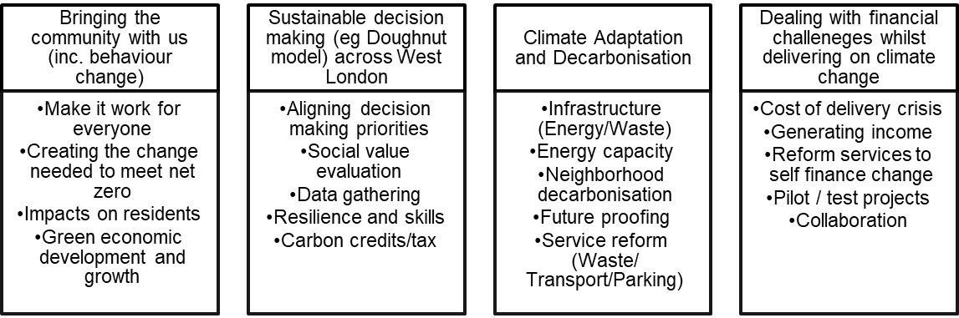
Key areas include behaviour change, data gathering, resilience and skills, social value evaluation and future proofing the system.
- Joint Waste Management Strategy
A key factor in the Joint Waste Management Strategy is the 65% recycling target. To meet this a framework of a joint plan for 2030 to be developed by WLWA and Boroughs was agreed in March 2022. The joint plan must incorporate managing the rising cost of inflation which can only be countered in WLWA by reducing the amount of waste collected.
It is vital in this year that we:
- Increase the proportion of residents using the food waste service and
- Prevent waste at source in the recycling centres.
The agreed framework is shown below:
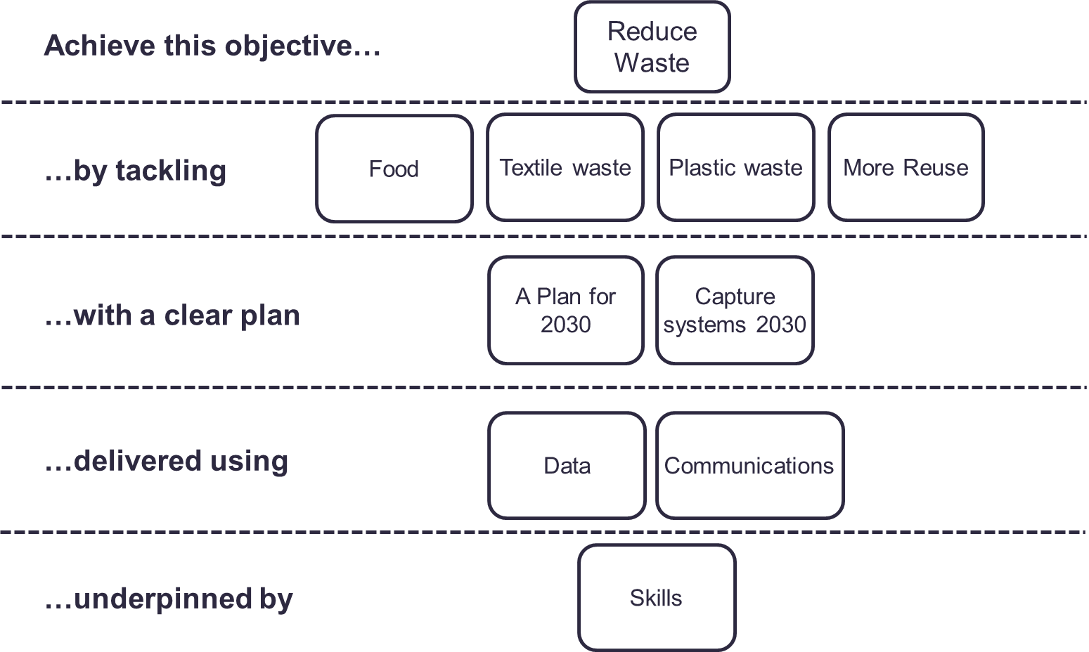
The programmes are intrinsically linked to the Authority’s Joint Waste Management Strategy and Business Plan. The projects are driving the design of the new policies and programmes through data, best practice and identification of opportunities, as well as delivering change to meet the desired outcomes and targets in the Strategy and the proposed Budget.

Contact Officers | Peter Tilston, Projects Director 07796 271 713  petertilston@westlondonwaste.gov.uk  Motoko Doolan, Net Zero Carbon Manager 07917 075 876  motokodoolan@westlondonwaste.gov.uk  Sarah Ellis, Strategic Development Lead 07584 631 710  sarahellis@westlondonwaste.gov.uk

Appendix 1

